Agenda Item: 2/02

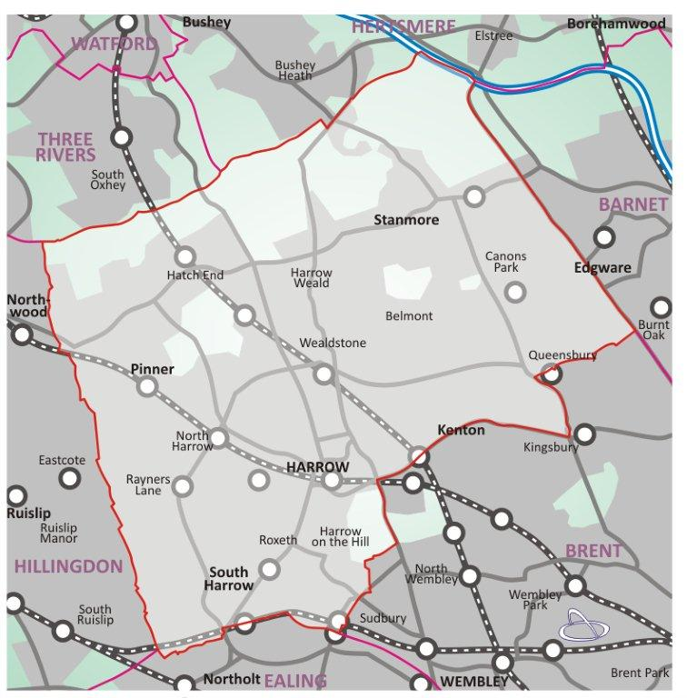

= application site

Land R/O 67 Drummond Drive, Stanmore. HA7 3PH | P/3467/22

Location Plan

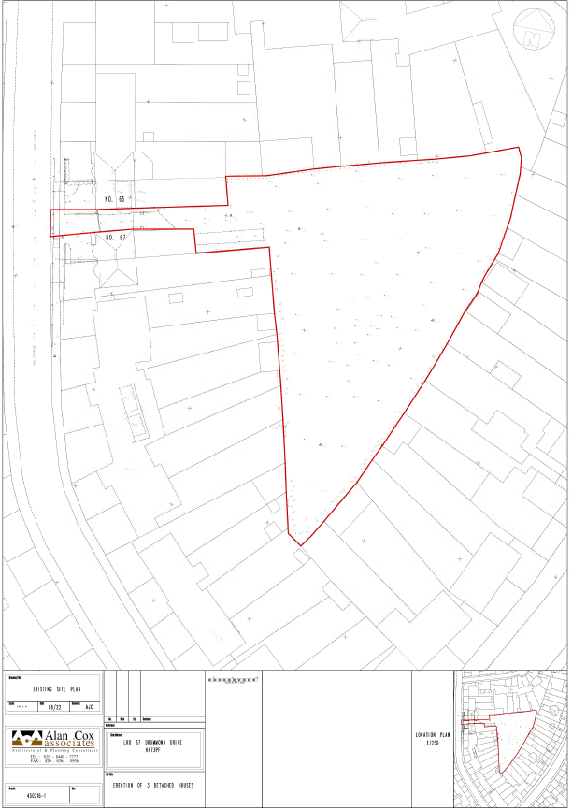

LONDON BOROUGH OF HARROW

PLANNING COMMITTEE

6th September 2023

APPLICATION NUMBER: | P/3467/22
VALIDATION DATE: | 17/10/2022
LOCATION: | LAND R/O 67 DRUMMOND DRIVE, STANMORE
WARD: | BELMONT
POSTCODE: | HA7 3PH
APPLICANT: | JAYMOND BADIANI
AGENT: | ALAN COX ASSOCIATES LTD
CASE OFFICER: | LUKE MCBRATNEY
EXPIRY DATE: | 15/12/2022

PROPOSAL

Three detached bungalows; Access Road; Enlargement of vehicle access between 65 and 67 Drummond Drive; Landscaping; Parking and Electric charging points; Refuse storage.

RECOMMENDATION

The Planning Committee is asked to:

- Agree the reasons for approval as set out in this report, and

- Grant planning permission subject to subject to the Conditions listed in Appendix 1 of this report.

REASON FOR THE RECOMMENDATIONS

The creation of three new dwellinghouses on the site is appropriate in this location and would not have an adverse impact on the amenity of future occupiers or the occupiers of adjoining properties.
Accordingly, weighing up the development plan policies and proposals, and other material considerations including comments received in response to notification and consultation as set out below, officers conclude that the application is worthy of support.

INFORMATION

This application is reported to Planning Committee as it proposes 3 additional residential dwellinghouses on the site recommended for grant, which is outside Part 1(b) of the Scheme of Delegation.

Statutory Return Type: | Minor Dwellings
Council Interest: | None
Net additional Floorspace: | 555sqm
GLA Community Infrastructure Levy (CIL) Contribution (provisional)(£60p/sqm): | £35,825
Local CIL requirement (Provisional) (£110p/sqm): | £96,809

HUMAN RIGHTS ACT

The provisions of the Human Rights Act 1998 have been taken into account in the processing of the application and the preparation of this report.

EQUALITIES

In determining this planning application, the Council has regard to its equality’s obligations including its obligations under section 149 of the Equality Act 2010.

For the purposes of this application there are no adverse equalities issues.

S17 CRIME & DISORDER ACT

Policy D11 of the London Plan (2021) and Policy DM1 of the Development Management Polices Local Plan require all new developments to have regard to safety and the measures to reduce crime in the design of development proposal. It is considered that the development does not adversely affect crime risk. However, a condition has been recommended for evidence of certification of Secure by Design Accreditation for the development to be submitted to and approved in writing by the Local Planning Authority before any part of the development is occupied or used.

- SITE DESCRIPTION

1.1 The subject site consists of a narrow section of land to the side of no. 67 Drummond Drive, providing a gated access route to a triangular piece of backland site of approximately 0.3 hectares. The rear gardens of 32 two storey semi-detached properties back onto and enclose the backland site, with these adjoining properties fronting onto The Highway, Alton Avenue and Drummond Drive.

1.2 The area is predominantly residential in character comprising semi-detached and terraced properties of generally 1930s and similar, traditional architectural styles, bays, gables, catslide roofs and other various articulation of facades are prominent.

1.3 The site has a Public Transport Accessibility Level (PTAL) of 1a/b, however, the site is within walking distance of bus stops served by H18/19.

1.4 The site is not within a conservation area and is not a listed building or within the vicinity of one. It is within a critical drainage area and a part of the front and rear corner of the site are within Surface Water Flood Zone 3a and 3b.

- PROPOSAL

2.1 Planning permission is sought for three detached bungalows that will be accessed from Drummond Drive via the land between no.65 and no.67. The backland site will be subdivided to provide each bungalow with private amenity space, landscaping, parking, electric charging points and refuse/recyclable waste storage area.

Revisions

2.4 The following revisions were requested during the determination period:

- Plans showing refuse storage at the front of the site.
- Window of bungalow was removed that overlooked properties on The Highway.

- RELEVANT PLANNING HISTORY

LBH/9334 | Erection of nine two-storied houses with integral garages – outline. | Refused  8/10/1973
LBH/9334/1 | erection of 7 terraced houses (with 5 integral garages) and pair of semi-detached Houses with integral garages (outline). | Granted  11/12/1974
LBH/21753 | 10 Terraced houses with access road, garaging and parking space (outline) | Refuse  5/8/1982  Dismissed at appeal
LBH/21994 | Outline: 9 terraced houses with access road | Refused 7/10/1982  Dismissed at appeal
LBH/22996 | demolition of no. 67 and erection of 8 semi detached & 1 detached house with Access road (outline) | Refused  26/5/1983
LBH/21753 | 10 terraced houses with access road, garaging and parking space (outline). | Refused  14/07/1983  Dismissed at appeal
LBH/39400 | Outline demolition of 67 Drummond Drive and erection of 8 semi-detached houses with garages and construction of access road | Refused  22/02/1990  Allowed at appeal
LBH/40838 | Outline: demolition of 67 drummond drive and erection of 6 semi-detached houses with garages and construction of access road and 2-storey side extension to no.69 | Refused  28/6/1990  Allowed at appeal
LBH/42619 | Demolition of 67 Drummond Drive and erection of eight semi-detached houses with garages, access road and parking, alterations and extension to no. 69 Drummond Drive | Granted  29/5/1991

The site has an extensive planning history that includes four appeals. The first two appeals were dismissed. However, the last two appeals in 1990 for development of six and eight houses on the plot and the demolition of no.67 to provide an access road were allowed (APP/M5450/A/90/153059 and APP/M5450/A/90/166419). The LPA granted a subsequent revised application for eight semi-detached houses in May 1991. These permissions have now lapsed and it is unclear why the scheme was not built out. An application in 2002 (ref EAST/875/02) was closed without a decision following considerable opposition from neighbouring residents and issues relating to the site boundaries and a restrictive covenant. Similar concerns were raised in relation to a later application in 2011 (ref: P/3312/10), which was found to be invalid and withdrawn.

- CONSULTATION

  - A total of 42 consultation letters were sent to neighbouring properties regarding this application. A site notice was also displayed. The overall expiry date of the first consultation was 07/11/2022.

4.2 A summary of the responses received along with the Officer comments are set out below:

- Loss of privacy
Officer comment:
The proposed dwellings are single storey and the windows facing neighbouring properties are limited. This would ensure additional views are limited.
- Issues relating to the onsite covenant
Officer comment:
This is not a material consideration; the applicant has confirmed on the application form this land is in the sole ownership of no.67. Issues relating to the covenant will be decided by the courts.
- No drainage report: potential increased flood risk
Officer comment:
Conditions have been attached to any forthcoming permission ensuring flooding details are provided before the commencement of the development.
- Concerns over security
Officer comment:
A secured by design condition would be attached to any forthcoming permission.
- Loss of views from rear gardens
Officer comment:
The dwellings are single storey and would have a limited impact of existing views.
- Proposed access road is not wide enough and will increase congestion in the surrounding area
Officer comment:
Details of vehicle access will be conditioned.
- Concern about the ability for emergency vehicles to access and turn within the development.
Officer comment:
Details of vehicle will be sought prior to the commencement of the development.

4.3 Statutory and Non Statutory Consultation

4.4 The following consultations have been undertaken, together with the responses received and officer comments:

LBH Highways

Insufficient Information to Support Application.

Observations:

This site is located in an area with a PTAL of 1a/b meaning access to public transport is considered to be very poor. The nearest bus stops are within a 7 minute walk from the site and are served by the H18/19 circular route running to/from Harrow Bus Station.

The nearest shops are a small parade at the junction of Kenton Lane and College Hill Road which is a 5 minute walk from the site.

Access and Parking:

Parking provision must not exceed the levels set in London Plan 2021 maximum parking standards which in this PTAL 1 location allows up to 1.5 spaces per dwelling.

The proposal includes retention of the existing vehicle crossing to allow access to the new houses and widening to the crossing for No. 67 Drummond Drive.

The access road should be configured as a road rather than a vehicle crossing to distinguish the uses. This would mean that a bell-mouth junction and separate vehicle crossings for Nos. 65 and 67 would be required. This would also result in the loss of a highway tree which would have to be replaced in accordance with Council policy.

The houses should have direct access on to the highway otherwise they can only be accessed by car from a private access road which may be acceptable to the present owners but could lead to issues in the future.

The planning statement indicates that HGV’s can access this site however, this would involve them driving between two houses; again this may be acceptable to the current residents but possibly wouldn’t be ideal for future households. The Council’s waste team are very unlikely to collect from this location and instead would require bins to be brought to the highway. Whilst the Planning Statement refers to a private company collecting refuse, I am still not satisfied that a design to allow HGV’s to safely enter and exit the site has been provided at this stage. The internal swept paths are noted but no tracking is provided for the junction with the highway.

Cycle parking:

The proposal requires a minimum of 2 secure and sheltered cycle parking spaces for each of the houses. Details of the stores including locations and dimensions are required prior to commencement.

Delivery and Servicing:

No information on deliveries and servicing apart from waste collections has been provided. This would need to be considered dependent on arrangements for the access and whether the site is gated or not.

Construction Logistics:

No information has been provided. A pre-commencement condition would be required securing a detailed plan written in accordance with TfL guidance.

Summary:

The proposal to provide houses in this location does not present a highway safety concern, however, further design work is required for the access road. For the proposal to be considered acceptable, a suitable arrangement needs to be agreed. Additionally, the site should ideally be gated to ensure security, details of which need to be agreed, and information on delivery and service and construction logistics are also required. At present, there is insufficient information for Highways to support this proposal.

Officer Comment:
Details will be secured by condition for each point raised.

Drainage

With regards to the above planning application, please see below our comments.

Drainage Requirements:
In line with our Development Management Policy 10, to make use of sustainable drainage measures to control the rate and volume of surface water runoff, to ensure separation of surface and foul water systems, make provision for storage and demonstrate arrangements for the management and maintenance of the measures used, the applicant should submit a surface water drainage strategy.
- The applicant should submit drainage details in line with our standard requirements attached.
- The applicant should consult Thames Water developer services by email: developer.services@thameswater.co.uk or by phone: 0800 009 3921 or on Thames Water website www.developerservices.co.uk regarding capacity of their public sewers for receiving additional discharge from the proposed development. The Thames Water confirmation letter should be submitted.

Proposed Parking/Hardstanding:
The use of non-permeable surfacing impacts upon the ability of the environment to absorb surface water, and hard surfacing of the front gardens and forecourts lead to localised surface water flooding. Hence the requirement for surface water to be contained within site and discharged to ground via the use of permeable paving or other suitable options.

Waste Management Policy Officer

No comments received.

Tree Officer

No objection subject to a site-specific tree protection plan and method statement (in accordance with BS5837:2012), outlining protection measures for the existing retained trees.

Officer Comment: This will be secured by condition of consent.
Urban Design Officer

No objection
Landscaping

The proposed areas for the amenity areas are the ‘left over’ spaces after setting out the three bungalows on the drawing. The amenity space is of limited use and value, small areas allocated for gardens and some of the spaces would be inaccessible, where the areas are small, tight pinch points, covered by the retained existing vegetation, particularly around the outside edges of the development. This would mean that some areas would be difficult to maintain so close to the proposed bungalows.

The tree report notes some significant trees, which Rebecca Farrar, Tree Officer can provide comments on. It must be noted that some trees neds to be lost as result of the proposed development. The vegetation to the west side, including T9 Leyland Cypress overhang the garden of house number 2 (middle house) and significantly compromise the available garden space which is already small. It is most likely there would be post development pressure for tree and vegetation removal to gain more outdoor space.

If you are minded to approve this application the following hard and soft landscape conditions would be required:
- Landscaping to be Approved - including landscape masterplan, hard and soft landscape details.
Soft landscape works to include:
Planting plans (at a scale not less than 1:100)
Schedules of plants, noting species, plant sizes, plant container sizes (all at time of planting) and proposed numbers / densities
Written specification of planting and cultivation works to be undertaken.
A landscape implementation programme with proposed timing / dates for the works.

- Hard landscape and materials details ( or can be included in the landscape condition above. Details of permeable hard surfacing, to include a cross section detail of the proposed construction.

- Boundary Treatment

- Levels – a detailed Levels Plan of the proposed finished levels. This document needs to fully explain details of the levels of the buildings, roads and footpaths in relation to the existing levels of the adjoining land and highways, and any other changes proposed in the levels of the site.

- Landscaping Scheme – Implementation and implementation programme, including a period of 5 year period for replacements of soft landscape.

- Secure and screened bin and bike storage

- POLICIES

5.1 Section 38(6) of the Planning and Compulsory Purchase Act 2004 requires that:

‘If regard is to be had to the Development Plan for the purpose of any determination to be made under the Planning Acts, the determination must be made in accordance with the Plan unless material considerations indicate otherwise.’

5.2 The Government has issued the National Planning Policy Framework [NPPF 2021] sets out the Government’s planning policies for England and how these should be applied and is a material consideration in the determination of this application.

5.3 In this instance, the Development Plan comprises The London Plan 2021 [LP] and the Local Development Framework [LDF]. The LDF comprises The Harrow Core Strategy 2012 [CS], Harrow and Wealdstone Area Action Plan 2013 [AAP], the Development Management Policies, Local Plan 2013 [DMP], the Site Allocations Local Plan [SALP] 2013 and Harrow Local Area Map 2013 [LAP].

5.4 A full list of all the policies used in the consideration of this application is provided as Informative 1.

6.0 ASSESSMENT

6.1 The main issues are:

- Principle of the Development
- Character of the Area and Design
- Residential Amenity
- Traffic, Parking and Servicing
- Flood Risk and Drainage
- Fire Safety
- Permitted Development Restrictions

6.2 Principle of Development

6.2.1 The relevant policies are:

  - The National Planning Policy Framework (2021)
  - London Plan Policies H1 and H2

  - Policy CS1.A of Harrow's Core Strategy (2012)
  - Garden Land SPD

6.2.2 Having regard to the London Plan (2021) policies H1 and H2 and the Council’s policies and guidelines, it is considered that the proposal would provide an increase in housing stock within the Borough thereby complying with housing growth objectives.

6.2.3 The backland site has no planning designation. It is not garden land. The principle of developing the site for residential use was established by previous appeal decisions and a subsequent planning permission granted by the Council. The thrust of current development plan policy would support the use of this land as residential use, therefore the principle of development is acceptable.

6.3 Character of the Area and Design

6.3.1 The relevant policies are:

  - The National Planning Policy Framework (2021)
  - The London Plan (2021): D3
  - Harrow Development Management Policies (2013): DM1, DM23
  - Harrow's Core Strategy (2012): CS1
  - Mayor of London Housing Supplementary Planning Guidance (2016)
  - Supplementary Planning Document Residential Design Guide (2010)

6.3.2 The existing site is a triangular backland site bound on three sides by rear gardens, with an access road to the west adjoining Drummond Drive. The nature of the site means that any development presents limited impacts to the street scenes. As the development is of a single storey scale, it will be solely visible from the access road to Drummond Drive and from rear elevations and gardens of properties facing the site. Townscape and streetscape impacts are not considered to apply as the development would not be visible from Drummond Drive, Alton Avenue or The Highway..

6.3.3 The site is within an area of predominantly interwar two storey semi-detached dwellings with tiled hipped roofs. While the proposal for Modernist / contemporary single-storey dwellinghouses does not follow the prevailing architectural character of the area, the limited height and scale of development and its limited visibility from surrounding streets make this approach acceptable and such a development is not considered to harm the character of the wider area or specifically of neighbouring dwellings.

6.3.4 The Council’s Urban Design Officer has reviewed the development and considers that the massing is of an appropriate scale in relation to surrounding dwellings. Whilst it is acknowledged that each dwellinghouse would have a significant footprint when compared to the surrounding properties, these single forms are broken up through modulated massing and level changes in the flat roofs and a robust planting for the boundary would further help reduce the perceived massing of the development.

6.3.5 The proposed building type follows a typically early-twentieth century Modernist style. The elevations for all three properties are generally restrained and simply achieved in the Modernist manner, with limited visual interest and emphasising planar surfaces and rectilinear junctions.

6.3.6 Officers welcome the inclusion of flat roofs that are intended as green (biosolar) roofs and that PV panels have been incorporated. The use of green roofs will lessen the visibility of the development from first floor windows of neighbouring dwellings.

6.3.7 The use of white render is of concern given the increased prominence such a finishing material will create for the development in relation to its visibility from surrounding developments. Officers therefore find it prudent to attach a condition requiring the submission of details of the proposed external materials to be used. The use of black aluminium coping and windows is supported, as is the use of black-painted brickwork and black composite doors. Details of which should be submitted to the LPA, for approval in writing prior to commencement of above ground works.

6.3.8 The proposed bin and recyclable stores will be at the front of each property within their own curtilage. Further details of these stores will be secured by condition to ensure a high-quality finish.

6.3.9 Cycle stores are provided in the rear garden within purpose-built structures. They would be located in landscaped rear gardens and a range of outbuilding type structures can be seen in the wider area. As such, the proposed cycle stores are an acceptable feature within the setting, however details would be secured by way of condition.

6.3.10 Landscaping works are proposed within the front and subdivided rear gardens. Whilst landscaping is welcomed, the submitted details are limited. Therefore, further details regarding any landscaping will be sought by way of condition.

6.3.11 In conclusion, the proposal is considered to have an acceptable impact on the character and appearance of the wider area and is of an appropriate design.

6.4 Residential Amenity

6.4.1 The relevant policies are:

  - The National Planning Policy Framework (2021)
  - The London Plan (2021): D3, D6,
  - Harrow Development Management Policies (2013): DM1, DM26
  - Harrow's Core Strategy (2012): CS1
  - Mayor of London Housing Supplementary Planning Guidance (2016)
  - Supplementary Planning Document Residential Design Guide (2010)
  - Technical housing standards - nationally described space standard (2016);

6.4.2 Impact of Development on Neighbouring Amenity

6.4.3 The rear gardens of 32 two storey semi-detached properties back onto the site and many of these properties have rear dormer extensions. The depth of the rear gardens varies, with the shortest ranging from 19-20metres. Whilst a number of these properties have mature trees in their rear gardens, additional tree planting around the subject site boundary would be required to reduce the impact of the development on the neighbouring occupiers in terms of privacy and overlooking.

6.4.4 This is consistent with the separation distances referred to in the London Housing Design Guide, which states

In the past, planning guidance for privacy has been concerned with achieving visual separation between dwellings by setting a minimum distance of 18-21m between facing homes. These are still useful yardsticks for visual privacy, but adhering rigidly to these measures can limit the variety of urban spaces and housing types in the city, and can sometimes unnecessarily restrict density.

6.4.6 Officers note that the side facing windows are located at ground floor level and would not result in additional views of neighbouring properties. It is therefore considered there would not be any harmful overlooking of neighbours resulting.

6.4.7 It is recognised that the siting of the access road to the sides of no.65 and no.67 Drummond Drive, would result in an increase in disturbance to the occupiers of these adjoining properties. However, appeal decision APP/M5450/A/90/153059 found that a 6-8 house development would not give rise to an unacceptable level of disturbance to neighbouring residents, therefore, it is considered that the proposed road to provide access for three dwellinghouses as opposed to eight homes would be acceptable in this regard.

6.4.8 The proposal is therefore considered acceptable in terms of neighbouring amenity impacts in accordance with the relevant policies.

Future Occupiers – Internal Configuration and Quality of Accommodation

6.4.9 Policy D6 of the London Plan specifies that boroughs should ensure that, amongst other things, ‘housing development should be of high quality design and provide adequately-sized rooms with comfortable and functional layouts’. It also sets out the minimum internal space standards for new dwellings. The use of these residential unit GIA’s as minima is also reiterated in Appendix 1 of the Residential Design Guide SPD. The National Technical Housing Standards provide additional detail.

6.4.10 Each dwellinghouse is 1 storey, 3 bedroom, 6 person, property and would have a Gross Internal Area (GIA) of approximately 185sqm. This exceeds the London Plan minimum GIA of 95sqm for properties of this size. Each bedroom would exceed the 11.5sqm required for a double bedroom. A minimum of 2.5m storage is required by the London Plan and each property provides sufficient storage.

6.4.11 All of the habitable rooms are provided with windows which allow for sufficient levels of natural light and adequate outlook.

6.4.12 London Plan seeks 2.5m floor to ceiling heights for 75% of the Gross Internal Area (GIA), the development provides a minimum of 2.5m floor to ceiling heights on all floor areas.

6.4.13 In regard to amenity space, the proposed dwellings would have separate private amenity space to the front, side, and rear of each unit. The proposed gardens spaces are of substantial size and are considered to be acceptable.

6.5 Traffic, Parking and Servicing

6.5.1 The relevant policies are:

  - The National Planning Policy Framework (2021)
  - The London Plan (2021): T4, T5, T6
  - Harrow Development Management Policies (2013): DM42, DM45
  - Harrow's Core Strategy (2012): CS1

6.5.2 Policies DM1 and DM42 of the DMP give advice that developments should make adequate provision for parking and safe access to and within the site and not lead to any material increase in substandard vehicular access.

6.5.3 The site lies within a Public Transport Accessibility Level (PTAL) of 1a/b (very poor). The London Plan advises a maximum parking rate of 1.5 space per dwelling. 2 parking spaces are proposed for each dwellinghouse. The parking provision is higher than permitted under the London Plan, however given the very poor PTAL and the large sizes of the dwellinghouses, these are considered to be acceptable in this case.

6.5.4 In respect to cycle parking, Policy T.5 and table 10.2 of The London Plan (2021) requires a minimum of 2 spaces per dwelling. The proposal shows cycle storage for each dwellinghouse within structures in each rear garden, which is considered acceptable.

6.5.5 The Council’s Code of Practice for Waste requires that each dwelling have a minimum 2-bin system, a garden waste bin is optional. In this instance, the proposed bins would be located along Drummond Drive. Further details are required and would be secured through a condition.

6.5.6 Officers note that highways officers have raised concerns regarding access to the proposed from Drummond Drive. In this instance, officers find it prudent to attach a condition requiring the submission of details on the means off access to the site from Drummond Drive.

6.6 Development and Flood Risk

6.6.1 The relevant policies are:

  - The National Planning Policy Framework (2021)
  - London Plan (2021): S1 12, SI 13
  - Harrow Development Management Policies (2013): DM9, DM10
  - Harrow's Core Strategy (2012): CS1

6.6.2 Policy DM9 B of the Development Management Policies Local Plan (2013) states, “proposals that would fail to make appropriate provision for flood risk mitigation, or which would increase the risk or consequences of flooding, will be refused.”.

6.6.3 The application site is located within a critical drainage area as defined by the maps held by the local drainage authority. Parts of the site is also within Surface Water Flood Zone 3a and 3b.
6.6.4 Policy DM10 was introduced to address surface water run-off and flood risk from developments. The conditions requested from drainage officers are recommended. In addition, informative for Sustainable Urban Drainage would be attached as well.

6.7 Fire Safety
6.7.1 Part A of Policy D12 of the London Plan (2021), requires the demonstration of suitably positioned and unobstructed space for fire appliances and evacuation assembly points, and that developments ensure robust strategies for evacuation are in place as well as confirmation of the fire-fighting water supply. A condition is recommended to ensure that a fully comprehensive fire strategy is provided prior to occupation.

6.8 Permitted Development Restrictions

6.8.1 It is considered that the extent of the proposed development has maximised the site potential, taking into account the overall scale, bulk and massing in relation to the character and appearance of the wider area.

6.8.2 As such, it is considered appropriate to restrict permitted development rights on each new dwelling in terms of future enlargements at the front, side and rear along with upward extensions and rear outbuildings.

6.8.3 Additionally, permission is only granted for single dwellinghouses, and it is not considered appropriate for future changes of use to HMOs to be possible given the differing impact these may have in terms of parking, site intensity and character of the wider area. As such, permitted development rights for the change of use from dwellings to small scale HMOs (Use Class C4) are recommended to be removed.
6.8.4 These restrictions on permitted development rights will be restricted by way of conditions of consent.

7.0 CONCLUSION AND REASONS FOR APPROVAL

7.1 The proposed development provides acceptable and policy compliant residential dwellinghouses for future occupiers and would not unduly impact on the character of the area or the amenities of the residential occupiers of the adjoining, or nearby properties, subject to the attached conditions. The proposed development would therefore accord with Policy D6 of the London Plan (2021), Policy CS1 of the Harrow Core Strategy 2012 and policies DM1, DM2, DM9; DM10, , DM27, DM42, DM45of the Harrow Development Management Policies Local Plan (2013).

APPENDIX 1: Conditions and Informatives

Conditions

- Timing

The development hereby permitted shall be begun before the expiration of three years from the date of this permission.
REASON: To comply with the provisions of Section 91 of the Town and Country Planning Act 1990

- Approved Drawing and Documents

The development hereby permitted shall be carried out, completed and retained in accordance with the following approved plans and document Schedule of application documents:

450216-1; 450216-2; 450216-4 Rev A; 450216-5; 450216-6; 450216-7; 450216-8; 450216-9; 450216-10; Ecological Assessment (Author: Cherryfield Ecology Dated: 27/09/2022); Design and Access Statement (Dated: 09/2022); Arboricultural Impact Assessment (Dated: 09/09/2022).

REASON: For the avoidance of doubt and in the interests of proper planning.

- Materials

Notwithstanding the details shown on the approved drawings, the development shall not progress beyond damp proof course level until samples of the materials (or appropriate specification) to be used in the construction of the external surfaces noted below have been submitted to, and agreed in writing by, the local planning authority:
  - All facing and roof materials for the buildings (including outbuildings);
  - windows/doors/glazing; and
  - Patio and hardstand materials.
The development shall be carried out in accordance with the details so agreed and shall be retained as such thereafter.
REASON: To ensure that the development is carried out to the highest standards of architecture and materials.

- Demolition and Construction Logistics Plan (Pre-commencement)

No development shall take place, including any works of demolition, until a detailed demolition and construction logistics plan has first been submitted to the Local Planning Authority to be agreed in writing. The plan shall detail the arrangements for:
  - the parking of vehicles of site operatives and visitors;
  - loading and unloading of plant and materials;
  - storage of plant and materials used in construction the development;
  - the erection and maintenance of security hoardings including decorative displays and facilities for public viewing;
  - wheel washing facilities;
  - a scheme for recycling/disposing of waste resulting from demolition and construction works;
  - measures for the control and reduction of dust;
  - measures for the control and reduction of noise and vibration; and
  - How traffic would be managed to minimise disruption.

The demolition and construction of the development shall be carried out in accordance with the plan so agreed.
REASON: To ensure that measures are put in place to manage and reduce noise and vibration impacts during demolition and construction and to safeguard the amenity of neighbouring occupiers, and to ensure that the transport network impact of demolition and construction work associated with the development is managed. To ensure that measures are agreed and in place to manage and reduce dust, noise and vibration during the demolition and construction phases of the development and manage transport impacts during the demolition and construction phases of the development. This condition is a PRE-COMMENCEMENT condition as the proposed measures must be in place prior to commencement of works.

- Levels to be Approved

No site works or development shall commence until details of the levels of the building(s), road(s) and footpath(s) in relation to the adjoining land and highway(s), and any other changes proposed in the levels of the site, have been submitted to, and approved by, the local planning authority.
REASON: To ensure that the works are carried out at suitable levels in relation to the highway and adjoining properties in the interests of the amenity of neighbouring residents, the appearance of the development, drainage, gradient of access and future highway improvement.

6. Sewage Disposal

The development hereby permitted shall not be commenced until works for the disposal of sewage have been provided on site in accordance with details to be submitted to, and approved in writing by, the local planning authority. The works shall be completed in accordance with the approved details and shall thereafter be retained.
REASON: To ensure that adequate drainage facilities are provided.

7. Surface Water Disposal
The development of any buildings hereby permitted shall not be commenced until works for the disposal of surface water and surface water attenuation and surface water storage works have been submitted to, and approved in writing by, the local planning authority. The works shall be completed in accordance with the approved details and shall thereafter be retained.
REASON: To ensure that adequate drainage facilities are provided, reduce and mitigate the effects of flood risk following guidance in the National Planning Policy Framework.

8. Highway Access

The development hereby permitted shall not commence until details of the means of vehicular access have been submitted to, and approved in writing by, the Local Planning Authority. The development shall not be used or occupied until the works have been completed in accordance with the approved details and shall thereafter be retained.
REASON: To ensure that the proposed development does not prejudice the free flow of traffic or the conditions of general safety along the neighbouring highway.

- Green Roof
Prior to first occupation of the development full details of the Green Roof, with cross section of the construction and maintenance plan shall be submitted to and approved in writing by, the local planning authority. The development shall be carried out in accordance with these approved details and shall thereafter be retained.

REASON: To ensure that adequate drainage facilities are provided in accordance with policy DM10 of the Councils Development Management Policies Local Plan 2013.

- Landscaping to be Approved

The development hereby permitted shall not commence beyond damp proof course level until there has been submitted to, and approved in writing by, the local planning authority, a scheme of hard and soft landscape works, including permeable paving and the green roofs, which shall include a survey of all existing trees and hedgerows on the land, indicating those to be retained and those to be lost. Details of those to be retained, together with measures for their protection in the course of the development, shall also be submitted and approved, and carried out in accordance with such approval, prior to any demolition or any other site works, and retained until the development is completed. Soft landscape works shall include: planting plans, and schedule of plants, noting species, plant sizes and proposed numbers/densities.
REASON: To safeguard the appearance and character of the area, and to enhance the appearance of the development.

- Landscaping Implementation

All planting, seeding or turfing comprised in the approved details of landscaping shall be carried out in the first planting and seeding seasons following the occupation of the building(s), or the completion of the development, whichever is the sooner. Any existing or new trees or shrubs which, within a period of 5 years from the completion of the development, die, are removed, or become seriously damaged or diseased, shall be replaced in the next planting season, with others of a similar size and species, unless the local authority agrees any variation in writing.
REASON: To safeguard the appearance and character of the area, and to enhance the appearance of the development.

- Landscape Management Plan

A landscape management plan, including long term design objectives, management responsibilities and maintenance schedules for all landscape areas, other than small, privately owned, domestic gardens, shall be submitted to, and approved in writing by, the local planning authority prior to the occupation of the development or any phase of the development, whichever is the sooner, for its permitted use. The landscape management plan shall be carried out as approved for a minimum of 5 years.
REASON: To safeguard the appearance and character of the area, and to enhance the appearance of the development.

- Boundary Treatment

The development hereby permitted shall not be occupied until a plan indicating the positions, design, materials and type of boundary treatment to be erected for all boundary treatments has been submitted to, and approved in writing by, the local planning authority. The boundary treatment shall be completed before the development is occupied. The development shall be carried out in accordance with the approved details and shall thereafter be retained.

REASON: To safeguard the amenity of neighbouring residents and the character of the locality.

- Cycle Storage

Prior to the first occupation of development, details of a minimum of two covered and secure cycle parking spaces per dwellinghouse shall be submitted to and approved in writing by the Local Planning Authority. The cycle parking shall be made available prior to the occupation of the development maintained and retained thereafter.

REASON: To ensure the satisfactory provision of safe cycle storage facilities, to provide facilities for all the users of the site and in the interests of highway safety and sustainable transport.

- Refuse Storage

Notwithstanding the approved plans, the construction of the dwellinghouses hereby permitted shall not commence beyond damp proof course level until a scheme for:-
      - The storage and disposal of refuse/waste
      - and vehicular access thereto
has been submitted to, and approved in writing by, the local planning authority. The development shall not be occupied or used until the works have been completed in accordance with the approved details and shall thereafter be retained.
REASON: To ensure adequate standards of hygiene and refuse/waste collection without prejudice to the enjoyment by neighbouring occupiers of their properties.

- Solar Panels
Notwithstanding the plans hereby approved, details of the solar panels to ensure they are as unobtrusive as possible, in design with consideration of reflective characteristics and angle on installation, are to be provided to and approved in writing by, the Local Planning Authority prior to the installation of the solar panels. The development shall be carried out in accordance with the details as so agreed and retained in that form thereafter.

Reason: To ensure the proposed panels do not detract from the overall appearance of the dwellings and wider area.

- Secure by Design Accreditation

Prior to the first occupation of the development, evidence of Secured by Design Certification (gold or silver) shall be submitted to the Local Planning Authority in writing to be agreed. Secure by design measures shall be implemented and the development shall be retained in accordance with the approved details.

REASON: In the interests of creating safer and more sustainable communities and to safeguard amenity by reducing the risk of crime and the fear of crime. the Local Plan (2013), and Section 17 of the Crime & Disorder Act 1998.

- Fire Safety

Prior to occupation a Fire Safety Statement shall be submitted to and approved in writing by the Local Planning Authority, this statement shall include details of how the development will function in terms of the following:
      - identify suitably positioned unobstructed outside space: a) for fire appliances to be positioned on b) appropriate for use as an evacuation assembly point
      - is designed to incorporate appropriate features which reduce the risk to life and the risk of serious injury in the event of a fire; including appropriate fire alarm systems and passive and active fire safety measures
      - is constructed in an appropriate way to minimise the risk of fire spread
      - provide suitable and convenient means of escape, and associated evacuation strategy for all building users
      - develop a robust management strategy for evacuation which is to be periodically updated and published (details of how often this management strategy is to be reviewed and published to be included), and which all building users can have confidence in
      - provide suitable access and equipment for firefighting which is appropriate for the size and use of the development.
The development shall be operated in accordance with the approved details in perpetuity.
REASON: To ensure that the fire safety of the proposed building is managed in a satisfactory manner and that the development contributes to fire safety in line with Policy D12A of the London Plan (2021). To ensure appropriate fire safety measures are approved before development is occupied.

- Balcony

The roof areas of the dwellinghouses hereby approved shall not be used as an amenity space for the occupiers of the dwellinghouses. Access to the roof shall be for maintenance purposes only.
REASON: To ensure that overlooking of the neighbouring properties cannot occur in the interests of the amenities of the neighbouring occupiers.

- Glazing

No window(s) / door(s), other than those shown on the approved plans and elevations shall be installed in the walls of the development without the prior permission in writing of the local planning authority.
REASON: To safeguard the amenity of neighbouring residents.

- Permitted Development Restriction 1

The development hereby permitted shall be used for Class C3 dwellinghouse(s) only and notwithstanding the provisions of the Town and Country Planning (General Permitted Development) (England) Order 2015 (or any Order revoking or re-enacting that Order with or without modification), no development within Schedule 2, Part 3, Class L shall take place.

REASON: To enable the Local Planning Authority to fully consider the effects of development normally permitted by the Town and Country Planning (General Permitted Development) Order 2015 to maintain mixed, balanced, sustainable and inclusive communities and in the interests of residential and visual amenity.

- Permitted Development Restrictions 2

Notwithstanding the provisions of the Town and Country Planning (General Permitted Development) Order 1995 (or any order revoking and re-enacting that order with or without modification), no development in relation to the existing and proposed dwellinghouses which would otherwise fall within Classes A, B, D, E, F and G in Part 1 of Schedule 2, and Class AA of Part 20 of Schedule 2 to that Order shall be carried out without the prior written permission of the local planning authority.

REASON: To safeguard the character of the area by managing the amount of site coverage and size of dwelling in relation to the size of the plot and availability of amenity space, biodiversity and to safeguard the amenity of neighbouring residents.

Informatives

1. Policies

The following policies are relevant to this decision:

National Planning Policy Framework (2021)
The London Plan (2021):
D3, D4, D6, T5, T6; H1, H2, H8; SI12
Harrow Core Strategy (2012):
CS1
Harrow Development Management Policies Local Plan (2013):
DM1, DM2, DM9; DM10, , DM27, DM42, DM45
Supplementary Planning Documents:
Supplementary Planning Document Residential Design Guide (2010)
Supplementary Planning Document Garden Land (2013)
Technical housing standards - nationally described space standard (2015).
Major of London Housing Supplementary Planning Guidance (2016)

2. Pre-application engagement

Statement under Article 35(2) of The Town and Country Planning (Development Management Procedures) (England) Order 2015This decision has been taken in accordance with paragraphs 39-42 of The National Planning Policy Framework. Pre-application advice was sought and provided and the submitted application was in accordance with that advice.

3. Considerate Contractor Code of Practice

The applicant's attention is drawn to the requirements in the attached Considerate Contractor Code of Practice, in the interests of minimising any adverse effects arising from building operations, and in particular the limitations on hours of working.

4. Party Wall Act

The Party Wall etc. Act 1996 requires a building owner to notify and obtain formal agreement from adjoining owner(s) where the building owner intends to carry out building work which involves:
1. work on an existing wall shared with another property;
2. building on the boundary with a neighbouring property;
3. excavating near a neighbouring building,
and that work falls within the scope of the Act.
Procedures under this Act are quite separate from the need for planning permission or building regulations approval. The Council has no remit regarding this Act and you are advised to seek independent professional advice from a party wall surveyor.
"The Party Wall etc. Act 1996: explanatory booklet" is available free of charge from:
www.gov.uk search "The Party Wall Act 1996 explanatory booklet"

5. Liability for Damage to Highway

The applicant is advised to ensure that the highway is not interfered with or obstructed at any time during the execution of any works on land adjacent to a highway. The applicant is liable for any damage caused to any footway, footpath, grass verge, vehicle crossing, carriageway or highway asset. Please report any damage to nrswa@harrow.gov.uk or telephone 020 8424 1884 where assistance with the repair of the damage is available, at the applicants expense. Failure to report any damage could result in a charge being levied against the property.

6. Surface and foul water connections

The applicant is advised that the Drainage Authority in Harrow recommends the submission of a drainage plan, for their approval, indicating all surface and foul water connections and their outfall details. Please also note that separate systems are used in Harrow for surface water and foul water discharge. Please email infrastructure@harrow.gov.uk with your plans.

7. Designing Out Crime

For further information regarding Secure By Design, the applicant can contact the North West London Designing Out Crime Group on the following: DOCOMailbox.NW@met.police.uk

8. INFORM67 - Fire Safety Statement. The submission/approval of the Fire Safety Statement does not replace the need for building regulation approval in relation to fire safety, nor does it convey or imply any approval under those regulations.

Thames Water

9. The applicant can contact Thames Water developer services by email: developer.services@thameswater.co.uk or by phone: 0800 009 3921 or on Thames Water website www.developerservices.co.uk for drainage connections consent.

10. Street Numbering

Harrow Council is responsible for the naming and numbering of new or existing streets and buildings within the borough boundaries. The council carries out these functions under the London Government Act 1963 and the London Building Acts (Amendment) Act 1939.
All new developments, subdivision of existing properties or changes to street names or numbers will require an application for official Street Naming and Numbering (SNN). If you do not have your development officially named/numbered, then then it will not be officially registered and new owners etc. will have difficulty registering with utility companies etc.
You can apply for SNN by contacting technicalservices@harrow.gov.uk or on the following link.
http://www.harrow.gov.uk/info/100011/transport_and_streets/1579/street_naming_and_numbering

Compliance with Planning Conditions

11. IMPORTANT: Compliance With Planning Conditions Requiring Submission and Approval of Details Before Development Commences - You will be in breach of planning permission if you start development without complying with a condition requiring you to do something before you start. For example, that a scheme or details of the development must first be approved by the Local Planning Authority. Carrying out works in breach of such a condition will not satisfy the requirement to commence the development within the time permitted.- Beginning development in breach of a planning condition will invalidate your planning permission.
- If you require confirmation as to whether the works you have carried out are acceptable, then you should apply to the Local Planning Authority for a certificate of lawfulness

12. Mayoral CIL
Please be advised that approval of this application (either by Harrow Council, or subsequently by the Planning Inspectorate if allowed on appeal following a refusal by Harrow Council) will attract a Community Infrastructure Levy (CIL) liability, which is payable upon the commencement of development. This charge is levied under s.206 of the Planning Act 2008 Harrow Council, as CIL collecting authority, has responsibility for the collection of the Mayoral CIL
The Provisional Mayoral CIL liability for the application, based on the Mayoral CIL levy rate for Harrow of £60/sqm is £35,825
The floorspace subject to CIL may also change as a result of more detailed measuring and taking into account any in-use floor space and relief grants (i.e. for example, social housing).

You are advised to visit the planning portal website where you can download the appropriate document templates.
Please complete and return the Assumption of Liability Form 1 and CIL Additional Information Form 0.
https://ecab.planningportal.co.uk/uploads/1app/forms/form_1_assumption_of_liability.pdf
https://ecab.planningportal.co.uk/uploads/1app/forms/cil_questions.pdf
If you have a Commencement Date please also complete CIL Form 6:
https://ecab.planningportal.co.uk/uploads/1app/forms/form_6_commencement_notice.pdf
The above forms should be emailed to HarrowCIL@Harrow.gov.uk
Please note that the above forms must be completed and provided to the Council prior to the commencement of the development; failure to do this may result in surcharges and penalties

13. Harrow CIL

Harrow has a Community Infrastructure Levy which applies Borough wide for certain developments of over 100sqm gross internal floor space.
Harrow's Charges are:
Residential (Use Class C3) - £110 per sqm;
Hotels (Use Class C1), Residential Institutions except Hospitals, (Use Class C2), Student Accommodation, Hostels and HMOs (Sui generis) - £55 per sqm;
Retail (Use Class A1), Financial & Professional Services (Use Class A2), Restaurants and Cafes (Use Class A3) Drinking Establishments (Use Class A4) Hot Food Takeaways (Use Class A5) - £100 per sqm
All other uses - Nil.
The Provisional Harrow CIL liability for the application, based on the Harrow CIL levy rate for Harrow of £110/sqm is £96,809
This amount includes indexation which is 326/224. The floorspace subject to CIL may also change as a result of more detailed measuring and taking into account any in-use floor space and relief grants (i.e. for example, social housing).
The CIL Liability is payable upon the commencement of development.
You are advised to visit the planningportal website where you can download the relevant CIL Forms.
Please complete and return the Assumption of Liability Form 1 and CIL Additional Information Form 0.
https://ecab.planningportal.co.uk/uploads/1app/forms/form_1_assumption_of_liability.pdf
https://ecab.planningportal.co.uk/uploads/1app/forms/cil_questions.pdf
If you have a Commencement Date please also complete CIL Form 6:
https://ecab.planningportal.co.uk/uploads/1app/forms/form_6_commencement_notice.pdf
The above forms should be emailed to HarrowCIL@Harrow.gov.uk
Please note that the above forms must be completed and provided to the Council prior to the commencement of the development; failure to do this may result in surcharges.

14 SUDS
Surface water run-off should be controlled as near to its source as possible through a sustainable drainage approach to surface water management (SUDS). SUDS are an approach to managing surface water run-off which seeks to mimic natural drainage systems and retain water on or near the site as opposed to traditional drainage approaches which involve piping water off site as quickly as possible.
SUDS involve a range of techniques including soakaways, infiltration trenches, permeable pavements, grassed swales, ponds and wetlands. SUDS offer significant advantages over conventional piped drainage systems in reducing flood risk by attenuating the rate and quantity of surface water run-off from a site, promoting groundwater recharge, and improving water quality and amenity. Where the intention is to use soakaways they should be shown to work through an appropriate assessment carried out under Building Research Establishment (BRE) Digest 365.
Support for the SUDS approach to managing surface water run-off is set out in the
National Planning Policy Framework (NPPF) and its accompanying technical guidance, as well as the London Plan.

CHECKED

Orla Murphy  Head of Development Management  24th August 2023 | Viv Evans  Chief Planning Officer  24th August 2023
APPENDIX 2: SITE PLAN
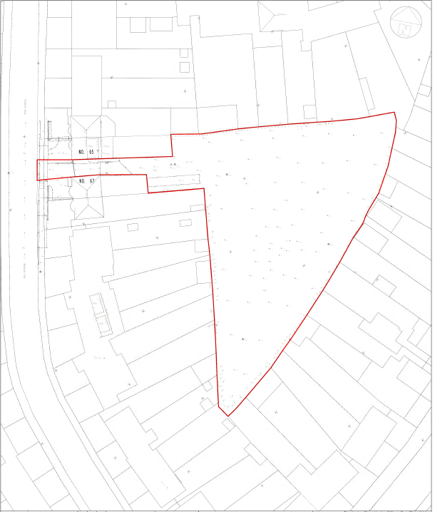

APPENDIX 3: SITE PHOTOGRAPHS

Front elevation
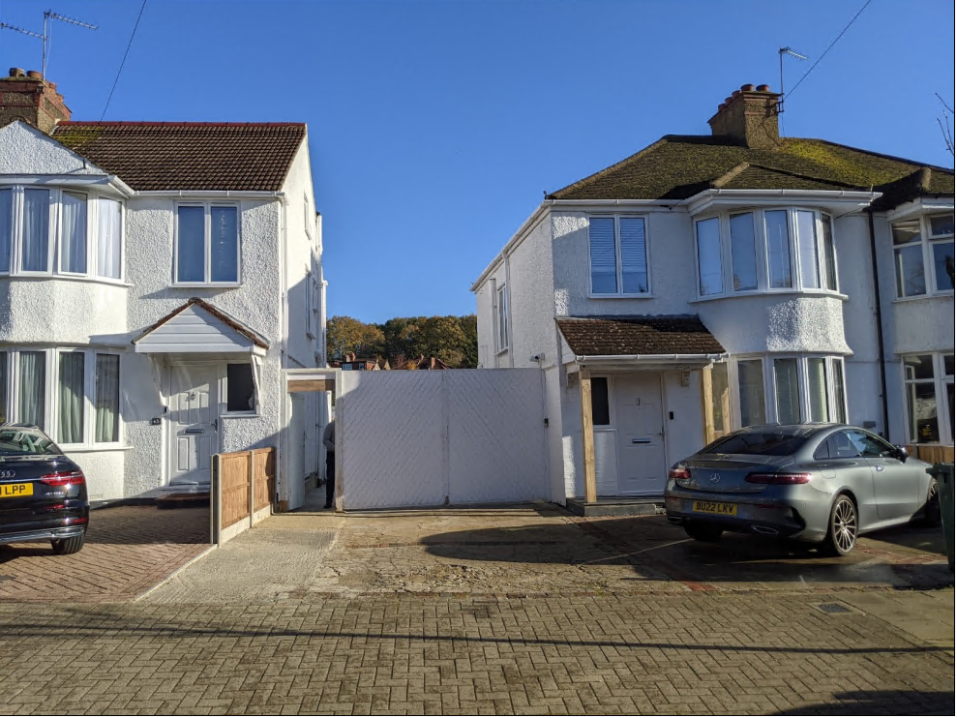

Rear Elevations of Nos. 65 & 67 Drummond Drive
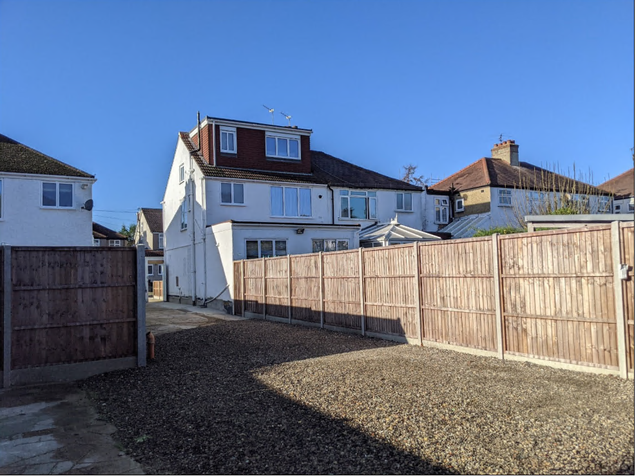

Site Boundaries and Existing Storage Unit on Site boundary and garage.

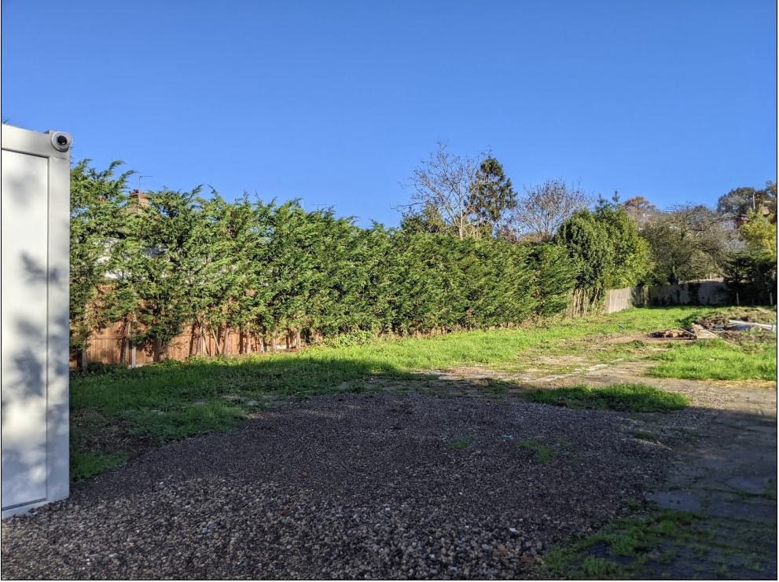
Rear of Alton Avenue

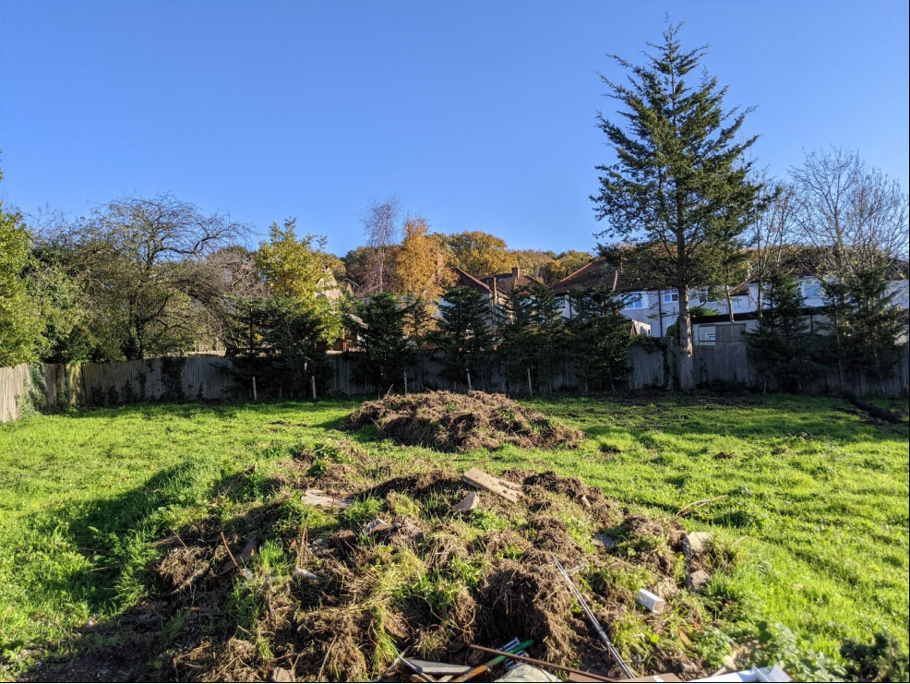
Rear boundaries of the Properties on The Highway

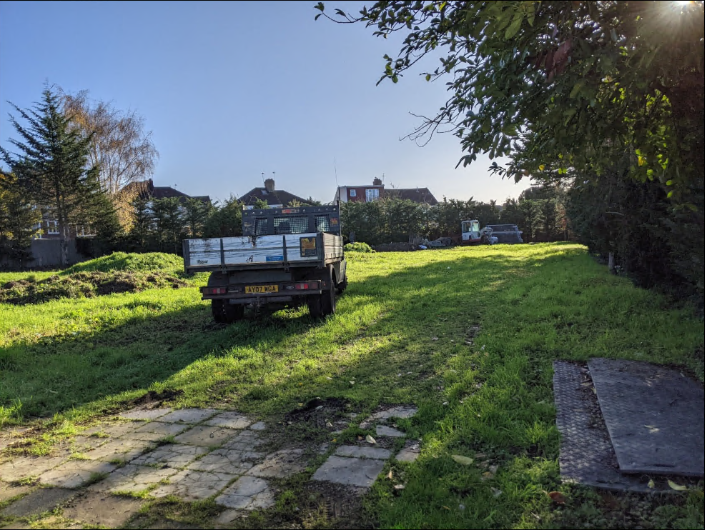

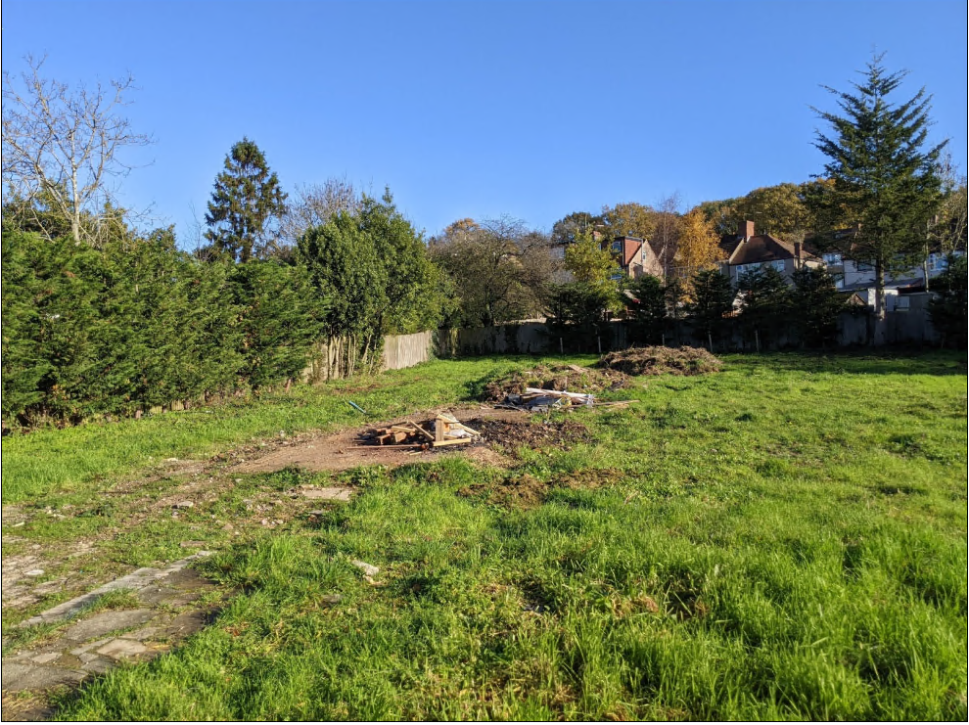

Aerial images
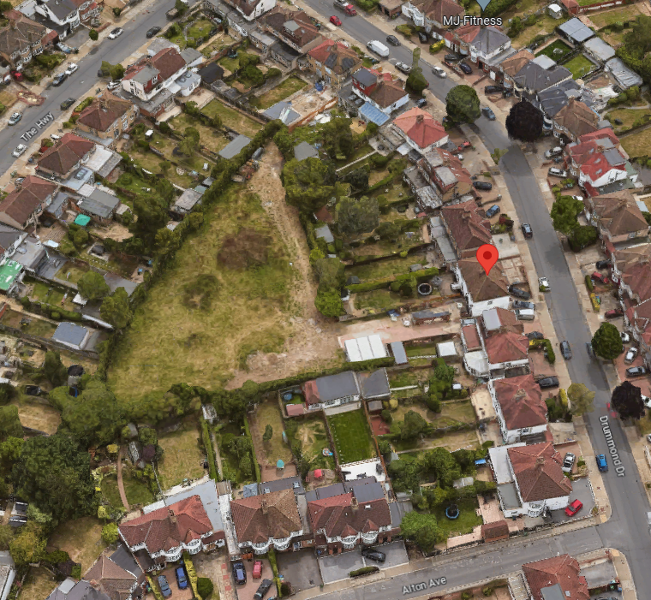

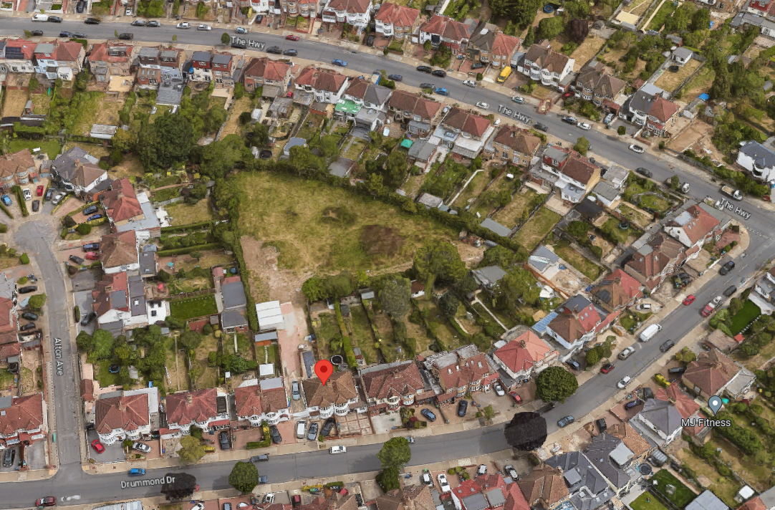

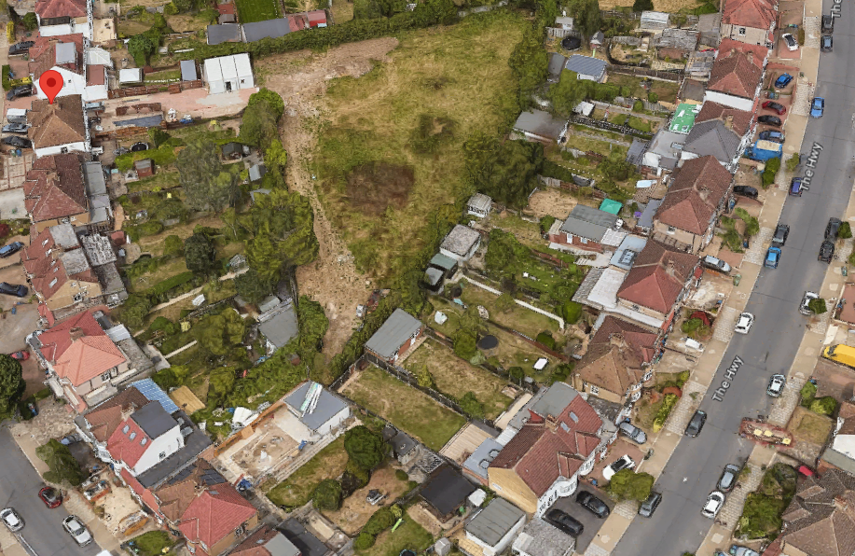

APPENDIX 4: PLANS AND ELEVATIONS

Existing site plan

Proposed site plan

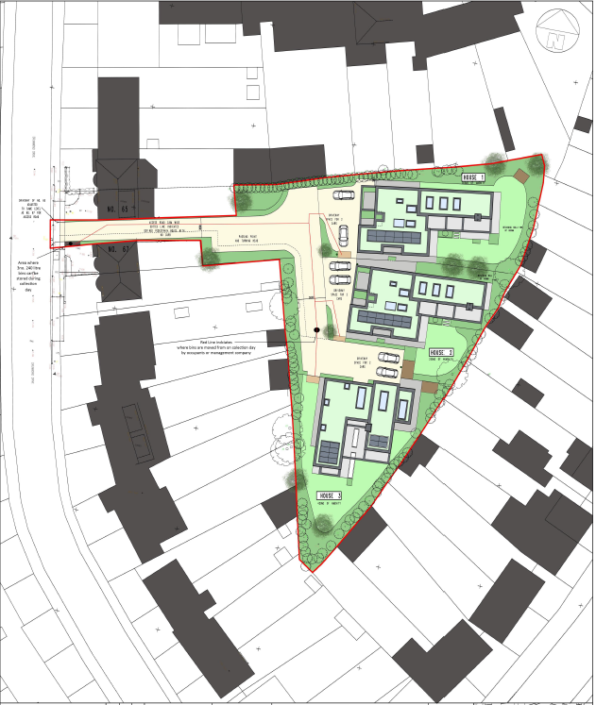

Proposed Elevations
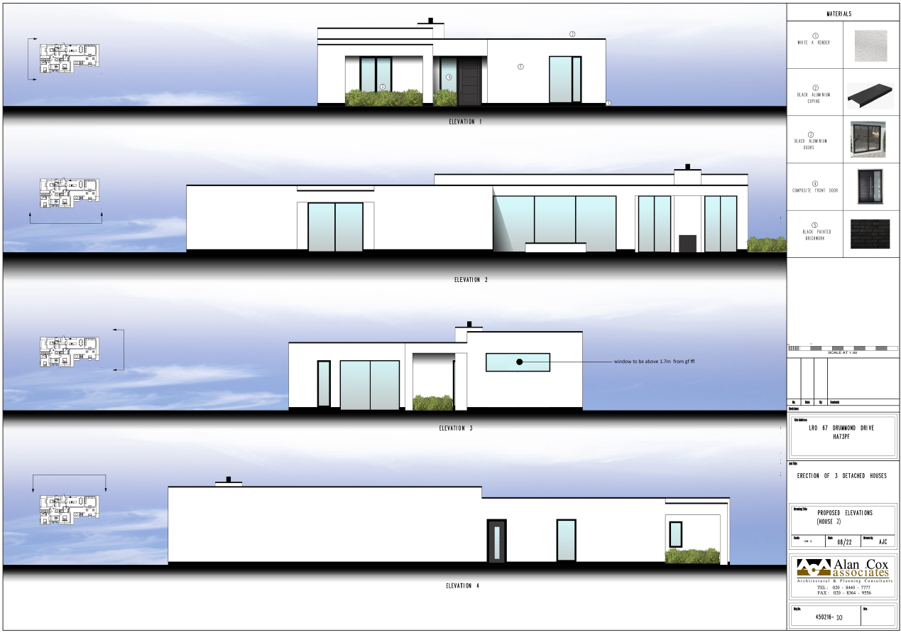

Proposed floor plans

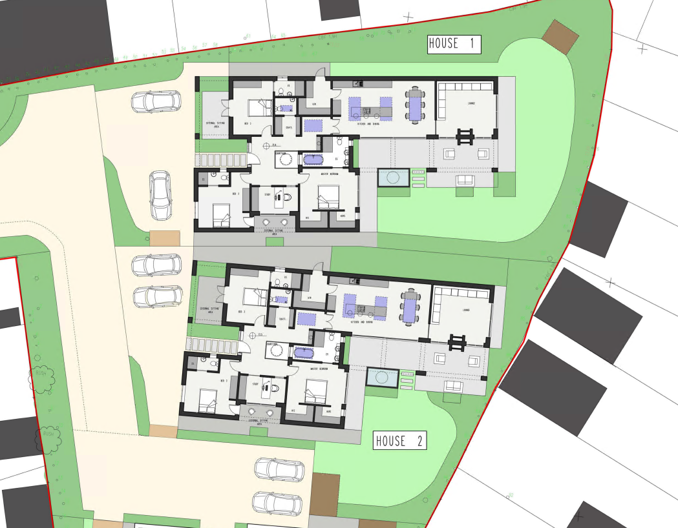
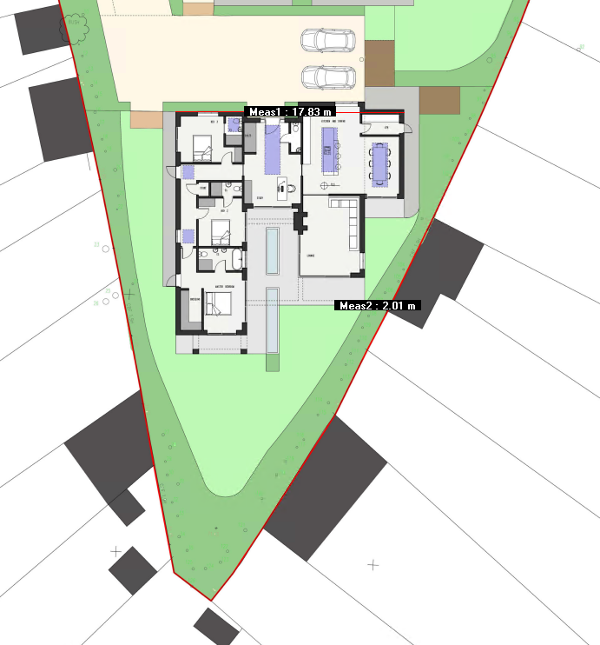

3D Visuals
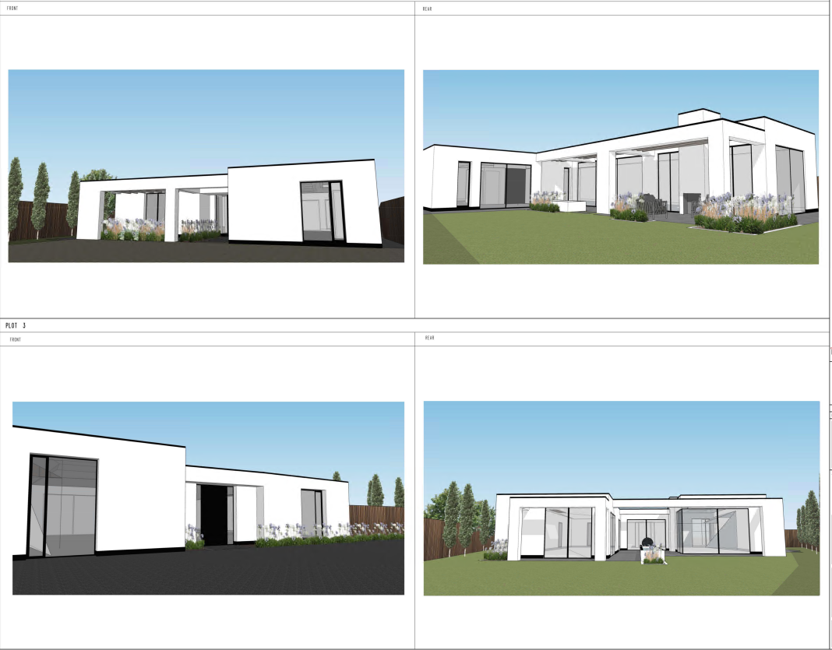

This page has been left intentionally blank

